BIG DATA

Name : S L A Laisha

USN : 1NT19IS147

Sec: C1

Date: 28.06.2022

5.TH PROGRAM ( HIVE )

Exercise-5: Extract facts using Hive :

1)Create and Drop Databases

2)Create, Alter , Drop Table

3)Built-in Operators

4)Built-in function

5)Views and Index

6)HIVEQL(select where , Select Order by, Select group by , Select Joins )

> cd $HADOOP_HOME/sbin

> ./start-all.sh

> jps

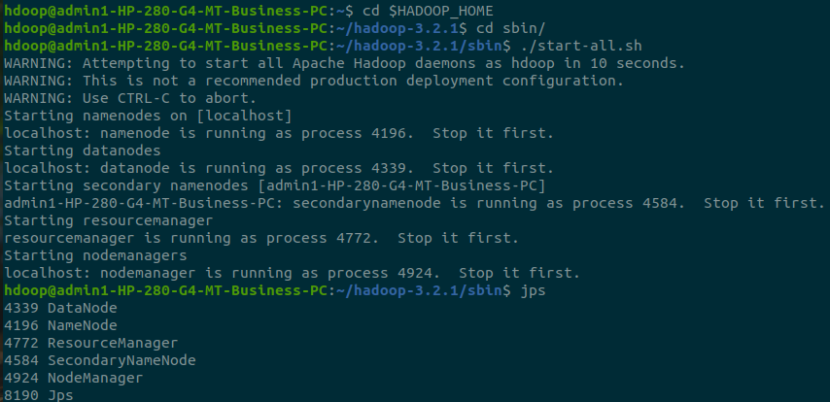

>cd $HIVE_HOME

> ./conf

> cd conf

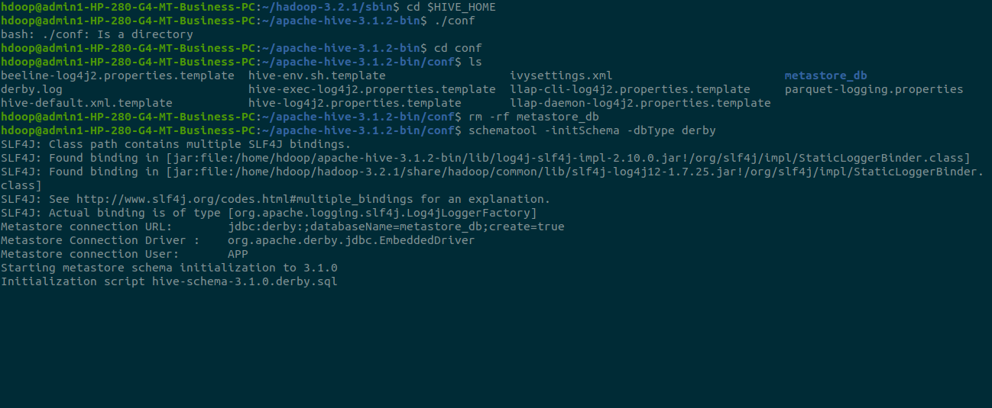

**To drop a database**

>rm -rf metastore_db



>hive

To view databases

>show databases;

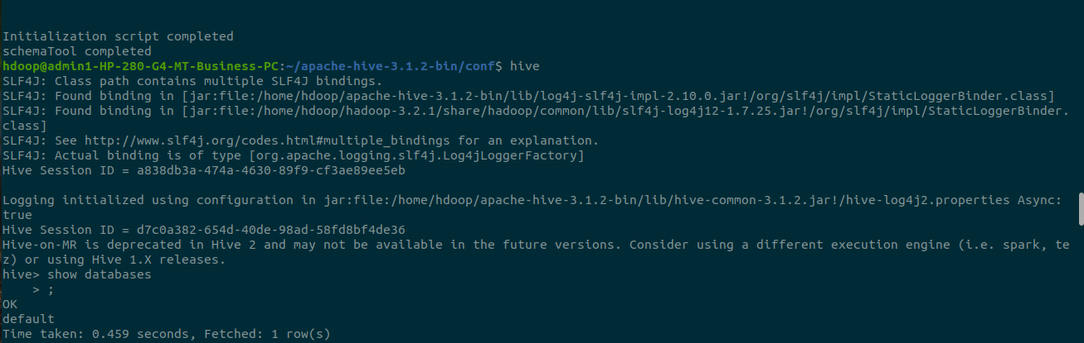

**To create database**

>create database if not exists salesdb;

>use salesdb;

**To create table**

>create table sales(product string,price int,payment_type string,name string,city string,state string,country string);

>desc sales;

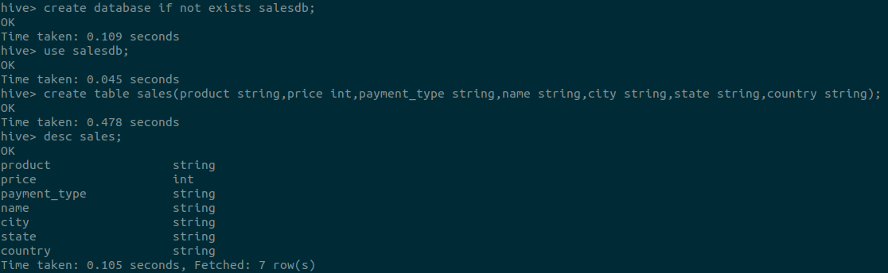

Inserting values:

hive> insert into sales values('product200',5000,'Mastercard','Kumar','Astoria','California','USA');

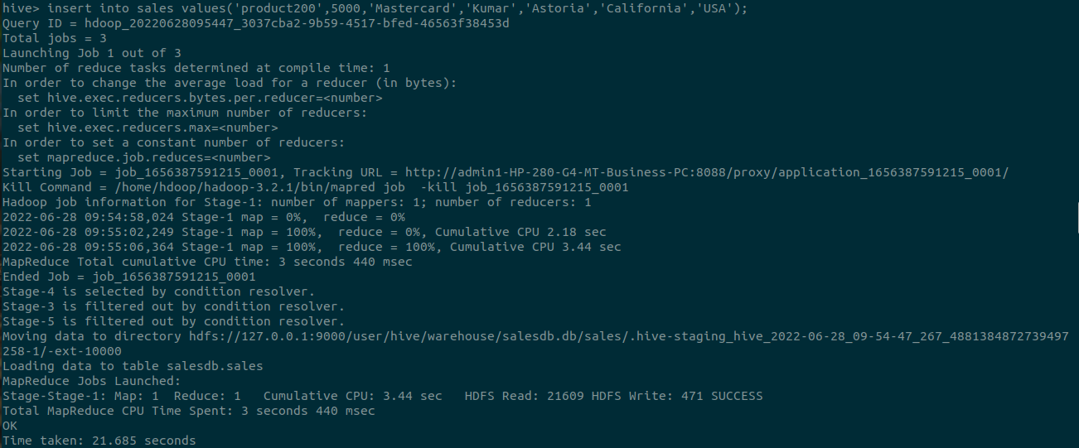

hive> insert into sales values('product201',1000,'Visa','Kamal','Bangalore','Karnataka','India');

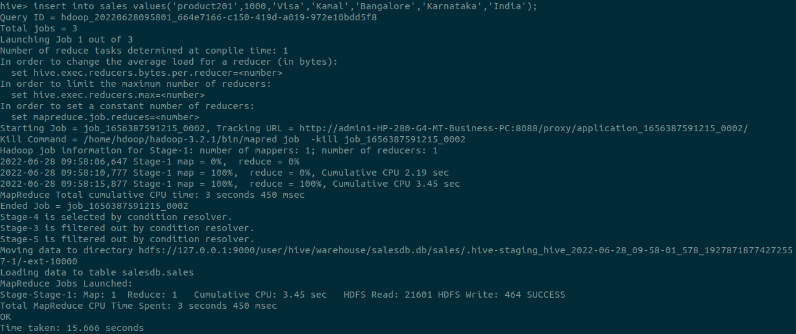

hive> insert into sales values('product202',8000,'Visa','Laisha','Amalapuram','Andhra Pradesh','India');

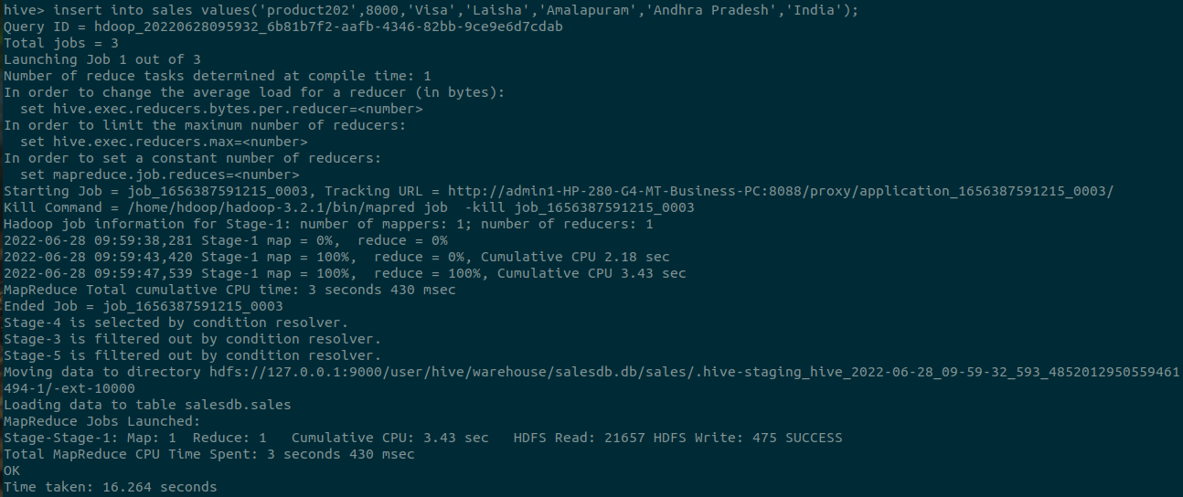

hive> insert into sales values('product203',2000,'Diners','Madeeha','Raichur','Andhra Pradesh','India');

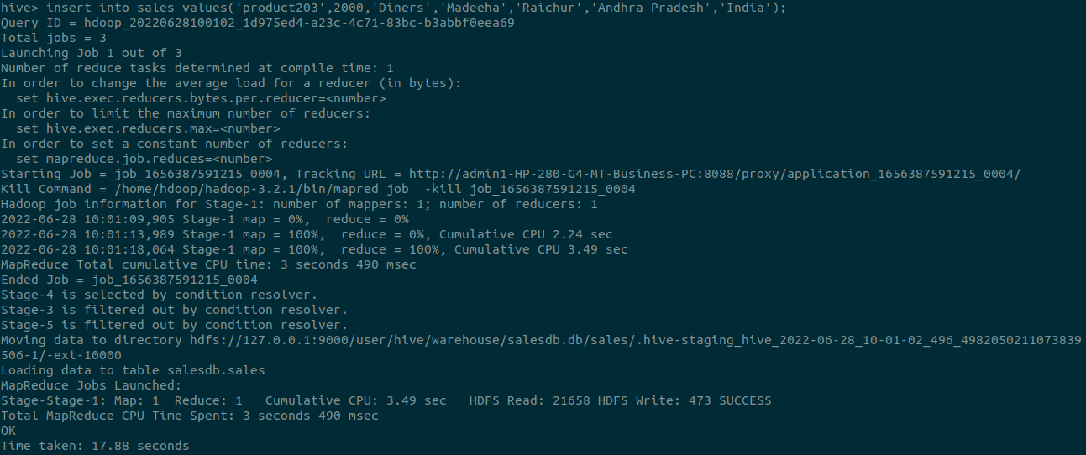

hive> insert into sales values('product204',2000, 'Mastercard','Isha', 'Mangalore', 'Karnataka', 'India');

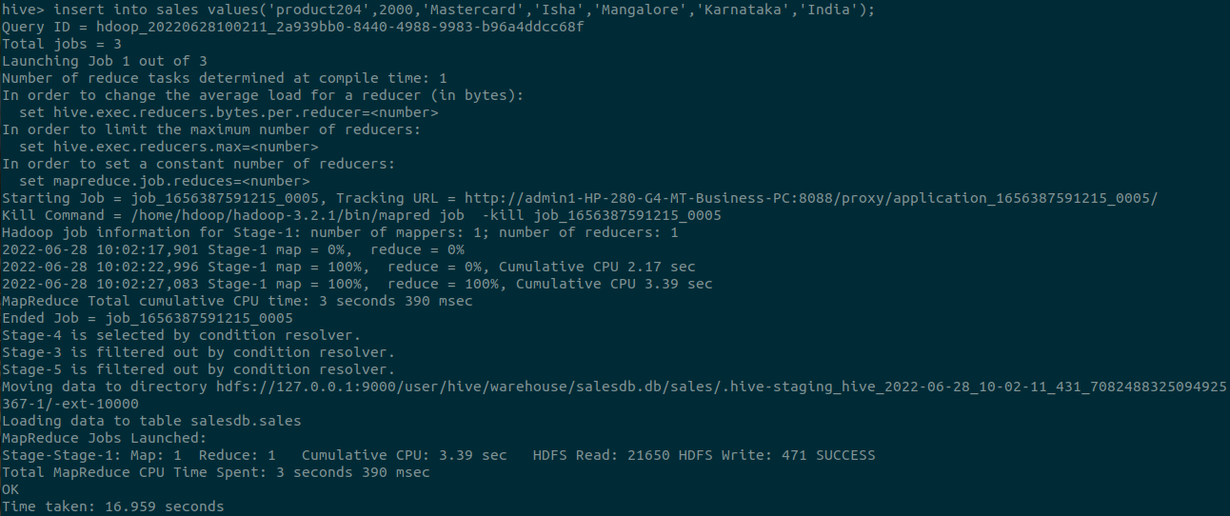

Queries:

hive> select * from sales;

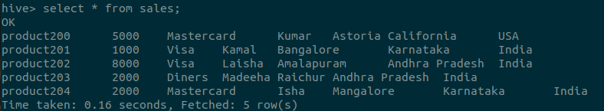

hive> select count(*) as count,Country from sales group by Country;

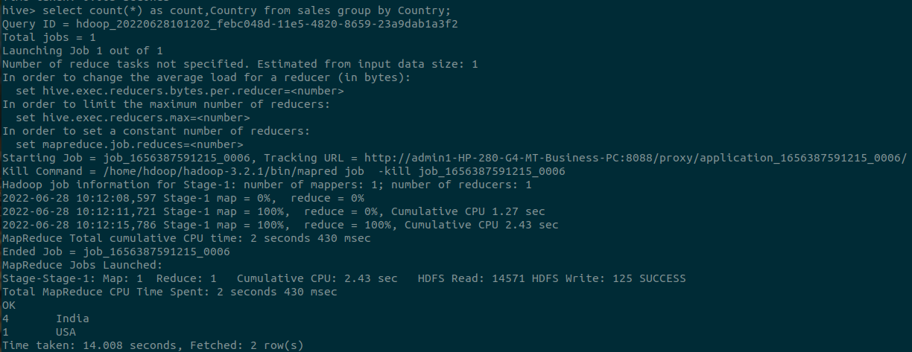

hive> select count(*) as count,State from sales group by State;

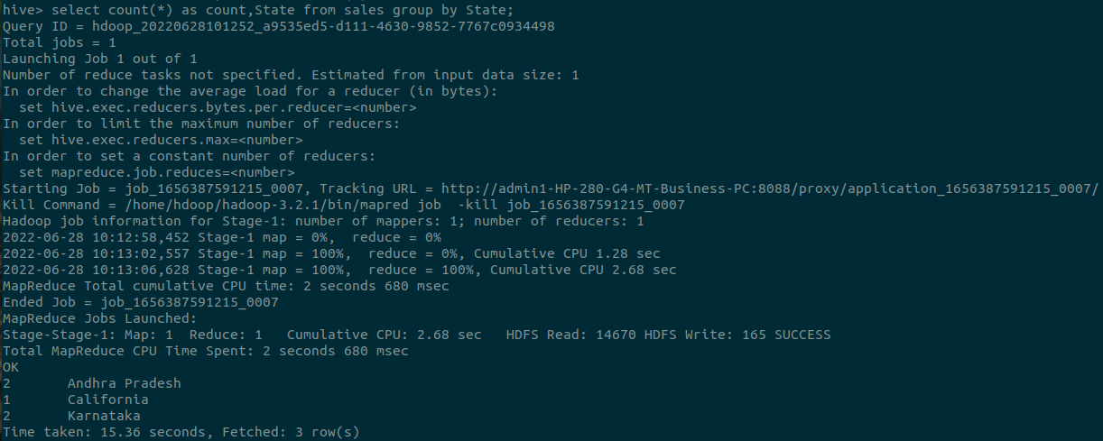

hive> select Product,Name from sales group by Product,Name;

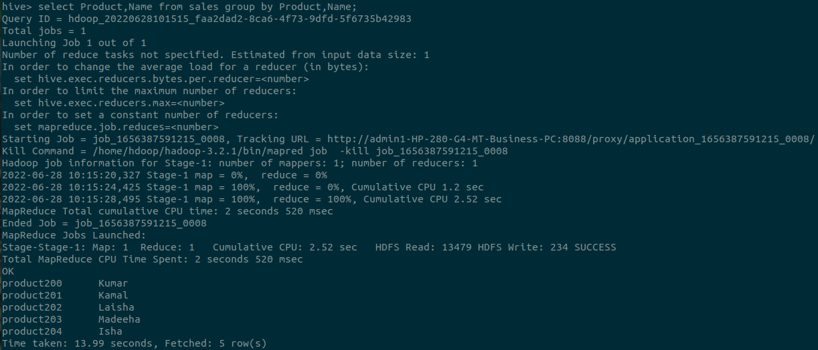

**views**

hive> create view visa as select * from sales where Payment_Type=’Visa’;

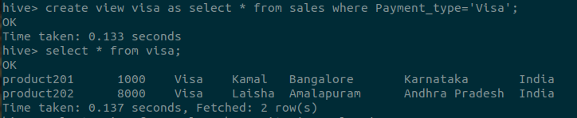

hive> select price from sales where city=’Bangalore’;





**alter table**

hive> alter table sales rename to 1NT19IS147sales;

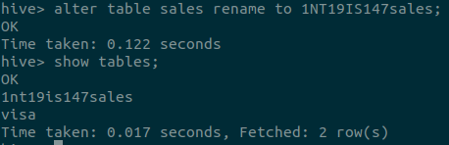

**Drop a table:**

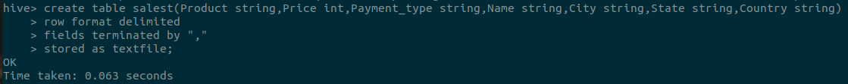



**Built-in operators:**

Arithmetic operators - Addition

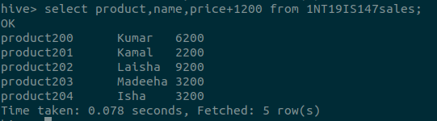

Relational operators( > )

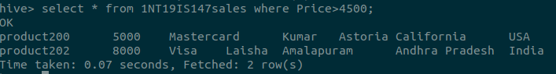

(between)

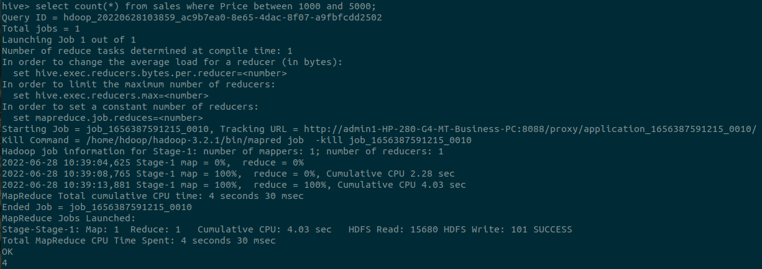

**built-in functions**

Mathematical functions

avg

hive> select avg(Price) from sales;

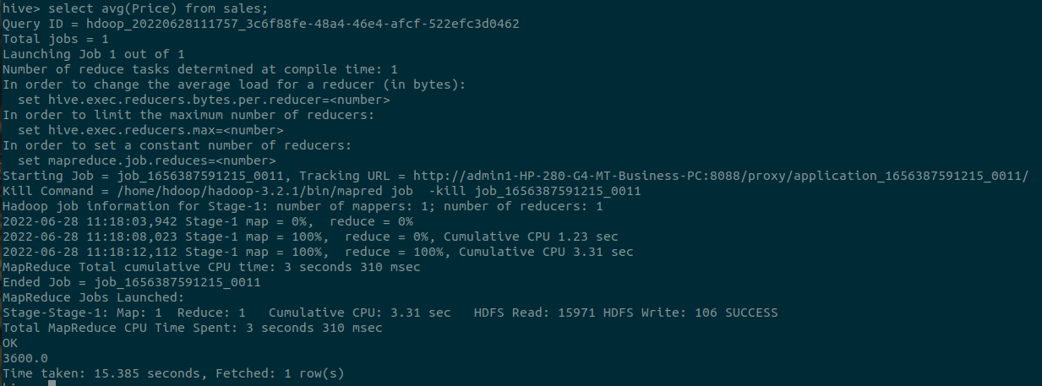

Aggregate functions:

Max

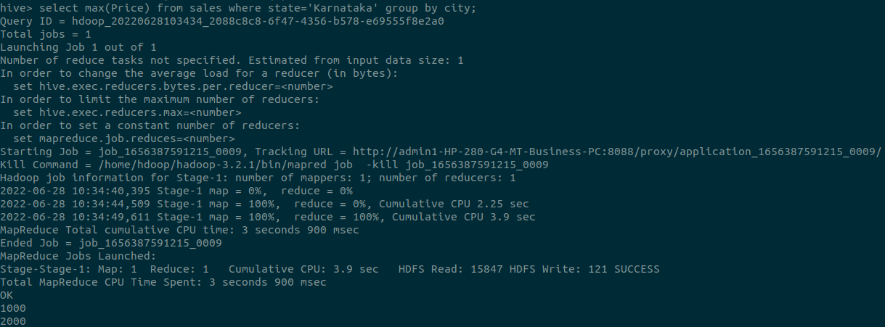

**Other built-in functions**

hive> select product, upper(Name) from 1NT19IS147sales;

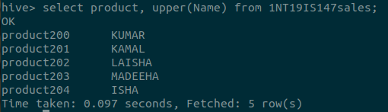

hive> select concat(Name,Country) from 1NT19IS147sales;

